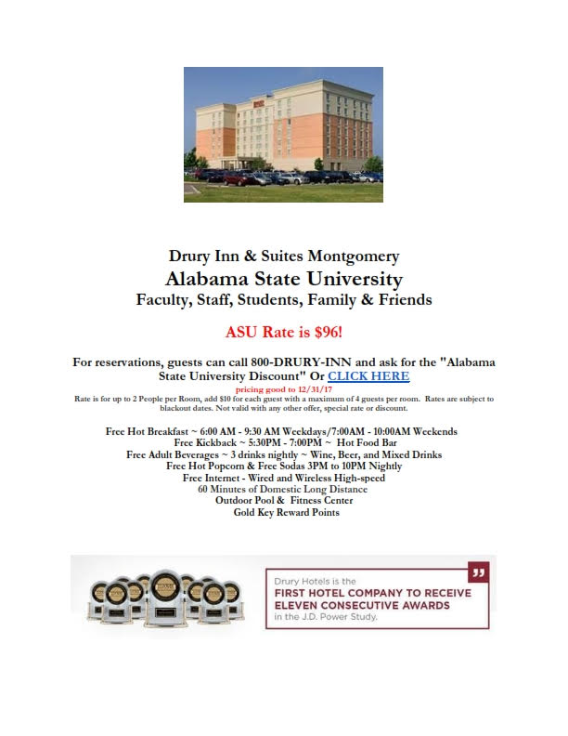

Amenities
- Free Hot Breakfast
- Free 5:30 Kickback®
- Free Wifi
- Free Soda & Popcorn (3-10 pm)
- Free 60 Minutes of Domestic Long Distance
- Free Local Phone Calls
- Free Parking
- Indoor/Outdoor Pool & Whirlpool
- 24-Hour Fitness Center
- 24-Hour Business Center
- Guest Pantry

